A robot is located at the top-left corner of a *m* x *n* grid (marked 'Start' in the diagram below).

The robot can only move either down or right at any point in time. The robot is trying to reach the bottom-right corner of the grid (marked 'Finish' in the diagram below).

How many possible unique paths are there?

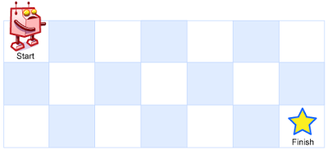  
Above is a 7 x 3 grid. How many possible unique paths are there?

**Note:** *m* and *n* will be at most 100.

**Example 1:**

**Input:** m = 3, n = 2

**Output:** 3

**Explanation:**

From the top-left corner, there are a total of 3 ways to reach the bottom-right corner:

1. Right -> Right -> Down

2. Right -> Down -> Right

3. Down -> Right -> Right

**Example 2:**

**Input:** m = 7, n = 3

**Output:** 28